**Assignment 1**

Name: Liu Zhaocheng;

NUID: 001326193;

Date: 20/01/2020;

**Q1 List nouns that are candidate classes or attributes:**

User, LMS, Widgets, Profile, Faculty, Student, Section, Course, Module, Lesson, Semester, Register Office, Evaluation, Exam, Assignment.

**Q2 List verbs as candidate relations between classes:**

Users register LMS;

LMS provides tools, LMS displays Widgets, LMS contains Profile;

Faculty creates profile, faculty teaches section;

Instructors consist of faculty;

Students sign up for sections, students have student progress, students create profile;

Widgets display topics,

Evaluation consists of Exams and assignments, evaluation evaluates students’ study progress,

Register office keeps track of student progress, register office create sections;

Courses have sections, courses contain different modules, courses open at different semesters;

Modules contain lessons; Lessons have order and topics;

**Q3 Generalization/specialization (inheritance, if applicable, explain) - show parts of your diagram that specifically illustrates the use of inheritance:**

The YouTube, Slides, text document and raw HTML have some specific attributes of themselves and share some same attributes from widgets. The faculty and student also have some same attributes from profile. As the figure below shows.

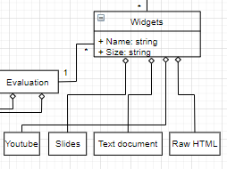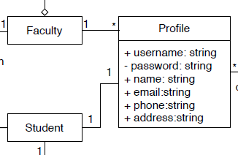

Figure1: Generalization/specialization

**Q4** **Associations,** **aggregation and/or composition, e.g., empty or filled in diamonds (1 to * or 1 to 1..*, if applicable, explain) - capture any lifecycle dependencies between classes using aggregation or composition.:**

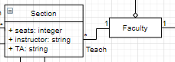Associations is a relationship which connect two things. In this case, “the faculty teaches sections” is an association relation.

Figure2: Association

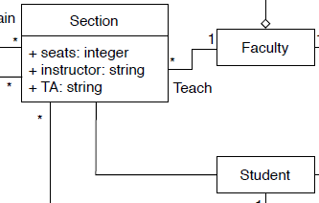Aggregation is a relationship that one class is aggregated by another class. For example, the section has students, and the student has different sections. So they have a aggregation relationship.

Figure3: Aggregation

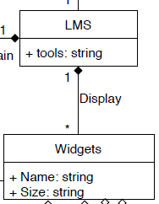For composition relationship, the one class relies on another class. And one class composes another.

Figure4: Composition

**Q5 Classes vs. attributes analysis**

1. The evaluation might have different parts, like the exam and assignment. So, the evaluation better to be a class rather than attributes.

2. The widget might have many kinds, and they all have restriction. So it is better to be a class have different subclasses.

**Q6 Correct data types**

In my diagram, there are different data types like integer, string, enumeration and so on. Like in the profile, the username, name and other attributes are string, and the number of seats in a section is integer.

**Q7 Cardinality**

For example, one student can have many sections and one student has only one profile. And one faculty can teach many sections, one faculty have one profile. And sections to semesters are many to many relations.

**Q8 Remove any inadequate or redundant relationships**

1. The relationship between faculty and course are redundant, there is a relationship between faculty and section, so there is no need to have more relationship between faculty and course.

2. The faculty already teaches the sections, so there is no need to have connection with the students.

3. The instructor is a subclass of faculty and the faculty already have profiles, so the instructor don’t need to connect to profile.

**Q9 Reify**

1. The widget should have specific attributes and contain subclasses. I add the size and name to the widget and draw the YouTube and other widgets as the subclass.

2. The semester should have specific attributes like the spring, fall… I add the semesters as attributes for the class.